HTML Forms, Media Elements

Forms :

<html>

<head>

<title>registration</title>

</head>

<body bgcolor="lightblue">

<form name="DOCTOR'S REGISTRATION FORM" bg>

<center>

<h1>DOCTOR'S REGISTRATION FORM:</h1>

<table allign="center">

<tr><td>Name:</td><td><input type="text" name="fname"></td></tr>

<tr><td>Username:</td><td><input type="text" name="uname"></td></tr>

<tr><td>Email Id:</td><td><input type="email" name="email"></td></tr>

<tr><td>Gender:</td><td><input type="radio" name="gender" value="male">Male<input type="radio" name="gender" value="Female">Female</td></tr>

<tr><td>Qualifications:</td><td><input type="checkbox" name="MBBS">MBBS<input type="checkbox" name="MD">MD<input type="checkbox" name="PhD,DPhil">PhD,DPhil</td></tr>

<tr><td>Specialisation in:</td><td><select name="Specialisation in"><option value="Paediatrics">Paediatrics</option>

<option value="Psychiatry">Psychiatry</option><option value="Radiology">Radiology</option><option value="Gynaecology">Gynaecology</option><option value="Medicine">Medicine</option><option value="Anaesthetics">Anaesthetics</option><option value="Surgery">Surgery</option></select> </td></tr>

<tr><td>Experience:</td><td><select name="experience"><option value="beginners">beginners</option>

<option value="below 10 yrs">below 10 years</option><option value="morethan 10 yrs">morethan 10 years</option></select> </td></tr>

<tr><td>Mobile Number:</td><td><input type="text" name="phoneno" size="10"></td></tr>

<tr><td>Create Password:</td><td><input type="password" name="pwd1"></td></tr>

<tr><td>Conform Password:</td><td><input type="password" name="pwd2"></td></tr>

<tr><td><input type="submit" name="submit" id="smt" value="submit"></td></tr>

<tr><td><input type="reset" name="reset" id="smt" value="reset"></td></tr>

</table></center>

</form>

</body>

</html>

OUTPUT:

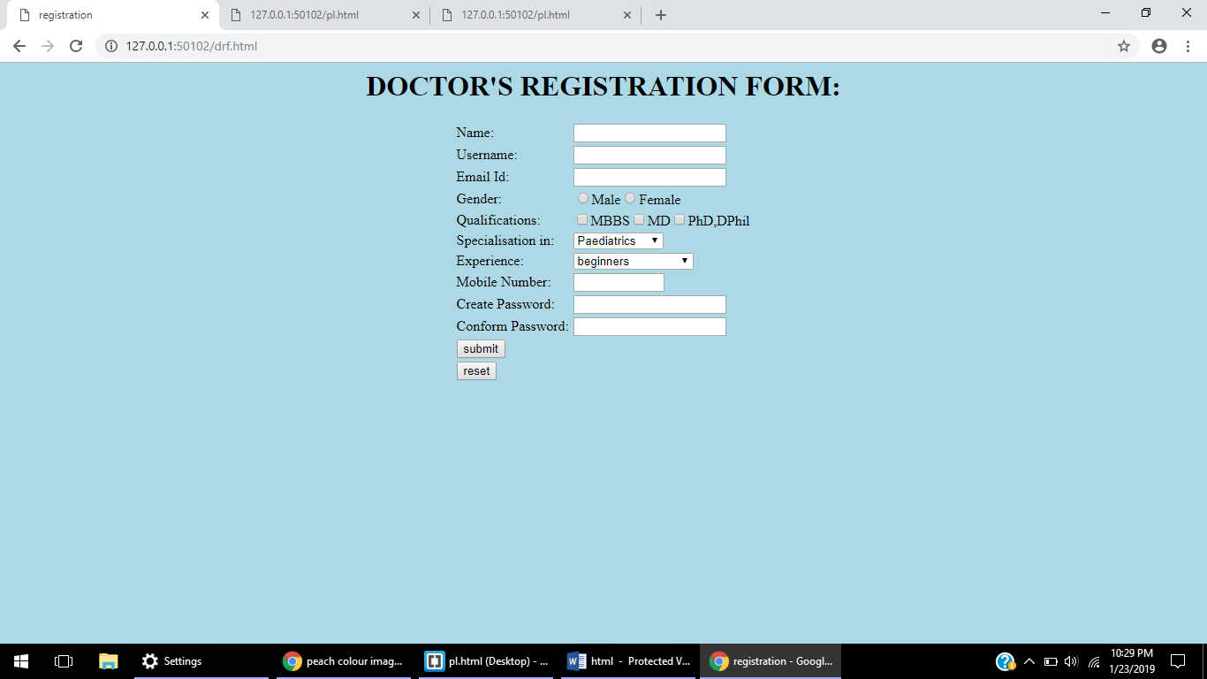

Media Elements :

<html>

<head>

<title> YOGA </title>

</head>

<body bgcolor="lightgrey">

<img src="ima.jpg" alt="image" height="400" width="600" ><h1> YOGA-WAY OF LIFE</h1>

<p>

Yoga is a great way to work on your flexibility and strength. Just about everyone can do it, too -- it's not just for people who can touch their toes or want to meditate.

Some types of yoga are about relaxation. In others, you move more. Most types focus on learning poses, called asanas. They also usually include attention to breathing.

<h2><font color="red"><ins>Breathing Benefits</ins></font></h2>

Yoga usually involves paying attention to your breath, which can help you relax. It may also call for specific breathing techniques.

But yoga typically isn't aerobic, like running or cycling, unless it's an intense type of yoga or you're doing it in a heated room.

<h2><font color="red"><ins>Less Stress, More Calm</ins></font></h2>

You may feel less stressed and more relaxed after doing some yoga.

Some yoga styles use meditation techniques that help calm the mind. Focusing on your breathing during yoga can do that, too.

<h2><font color="red"><ins>Good for Your Heart</ins></font></h2>

Yoga has long been known to lower blood pressure and slow the heart rate. A slower heart rate can benefit people with high blood pressure or heart disease, and people who've had a stroke.

Yoga has also been linked to lower cholesterol and triglyceride levels, and better immune system function.<br>

<video width="320" height="240" controls>

<source src="yoga.mp4" type="video/mp4">

</video>

<br>

The six branches are:

<ul>

<li>Hatha yoga:</li> This is the physical and mental branch designed to prime the body and mind.

<li>Raja yoga: </li> This branch involves meditation and strict adherence to a series of disciplinary steps known as the "eight limbs" of yoga.

<li>Karma yoga: </li> This is a path of service that aims to create a future free from negativity and selfishness.

<li>Bhakti yoga:</li> This aims to establish the path of devotion, a positive way to channel emotions and cultivate acceptance and tolerance.

<li>Jnana yoga:</li> This branch of yoga is about wisdom, the path of the scholar, and developing the intellect through study.

<li>Tantra yoga:</li> This is the pathway of ritual, ceremony, or consummation of a relationship.

</ul>

<h2><font color="red"><ins>Risks and side effects</ins></font></h2>

Yoga is low-impact and safe for people when a well-trained instructor is guiding the practice.

Injury due to yoga is an infrequent barrier to continued practice, and severe injury due to yoga is rare. However, consider a few factors before starting.

Anyone who is pregnant or who has an on-going medical condition, such as high blood pressure, glaucoma, or sciatica, should talk to their healthcare practitioner before practicing yoga. They may need to alter or avoid some yoga poses.

Beginners should avoid extreme poses and difficult techniques, such as headstand, lotus position, and forceful breathing.

When using yoga to manage a condition, do not replace conventional medical care with yoga or postpone seeing a healthcare provider about pain or any other medical problem.

</body>

</html>

OUTPUT:

